EyeBot7 Robot

EyeBot7 Robot is a fully self-contained mobile robot, based a Raspberry Pi 3+ with touch screen LCD and an EyeBot7 daughterboard including an Atmel CPU. Included are:

* Robot chassis
* Two drive motors with encapsulated encoders
* Embedded controller Raspberry Pi
* 16GB SD card with pre-installed software
* Auxiliary IO-Controller EyeBot 7 with ATxmega128A1U CPU
* Touch screen LCD
* 3 x infrared PSD distance sensors from Sharp
* 1 x Pi digital camera
* Lithium Polymer battery
* Mains Charger

On the software side:

* RoBIOS mobile robot operating system and library
* EyeSim simulation system for Windows, MacOS or Linux

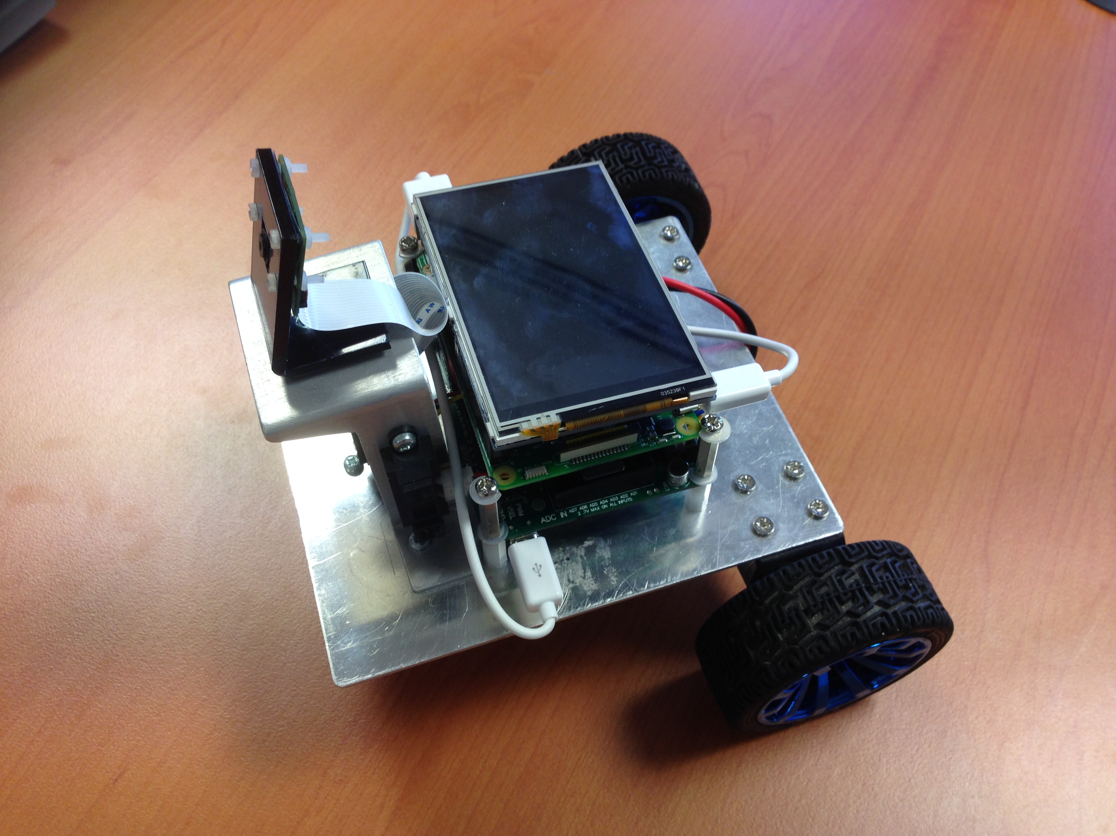 

Robot design ptototype

Full Documentation

**http://www.inrosoft.com/eyebot7/7r.pdf**