EyeBot7 Interface-Board

EyeBot7 is an embedded controller for robotics applications, including motor drivers, sensor interfaces, as general digital & analog IO. It can be linked via USB to any controller, especially Raspberry Pi and Beagle Bone, offering a number of additional digital and analog I/O lines as well as hardware and software device drivers to interface with low-level hardware. The board has a list of specific IO commands for communication with the host controller. The EyeBot7 IO-Board allows various types of inputs (digital, analog and encoders) and outputs (digital, RC, PWM and power PWM). The board features a powerful, high performance 8/16-bit AVR ATxmega128A1U microcontroller and uses USART micro USB port for serial communication with the host controller. If used with a Raspberry Pi, the extensive high-level robotics library RoBIOS can be used, which allows the simple design of robot application programs in C, C++, or Python.

Features

- High performance and low power 8/16-bit Atmel XMEGA128 A1U Microcontroller
- 14 PWM/servo outputs (8 are available to use, 6 are reserved for other use).
- 4 H-Bridge Motor drivers with configurable voltage supply pins and encoder feedback
- 16 digital I/O pins
- 8 Analog Input pins (ADC IN channels) and 6 additional analog pins (reserved for PSD)
- USART micro USB port
- 2 x 5VDC power supply outputs (1 USB 2.0 and 1 screw-type terminal)

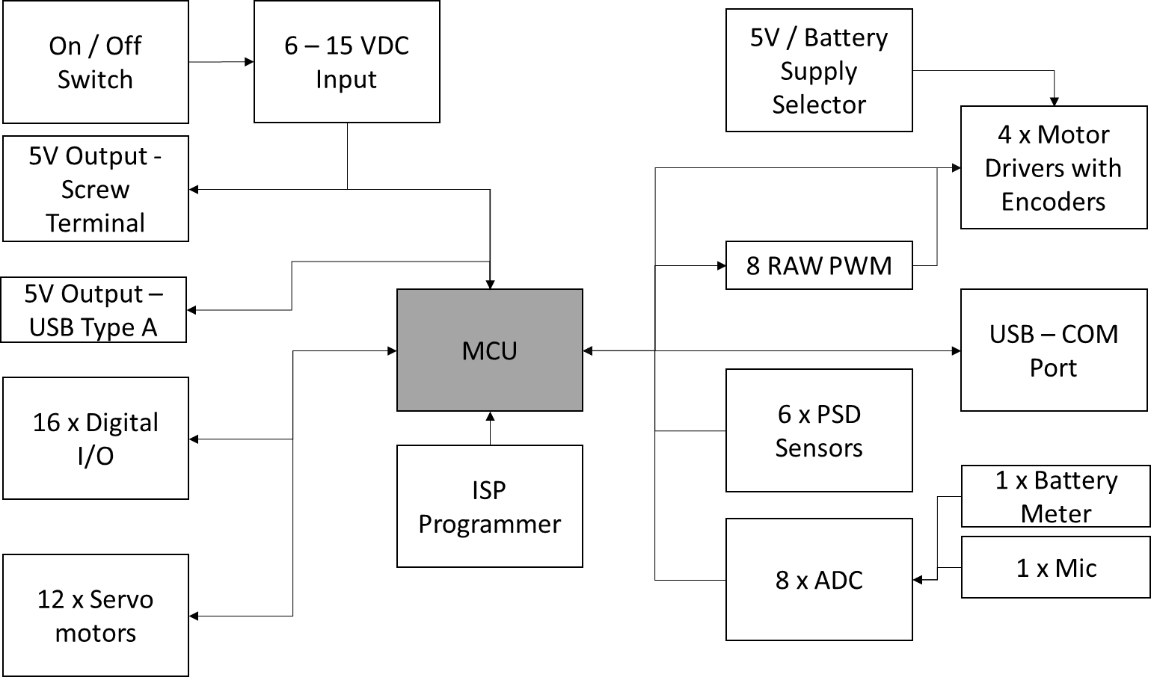

Full Documentation

http://www.inrosoft.com/eyebot7/7e.pdf

