The University of Western Australia
School of Engineering
Professor Thomas Bräunl

Robot Manipulators and Automation
AUTO4507
Group Project Industrial Robot Manipulator weeks 6-12
GROUPS: Form groups of 4 students
EQUIPMENT: UR5 Robot
TTGO controller
Your developed input device.
Design and build a scaled model of a UR5 robot that will serve as an input device to a real UR5 robot.

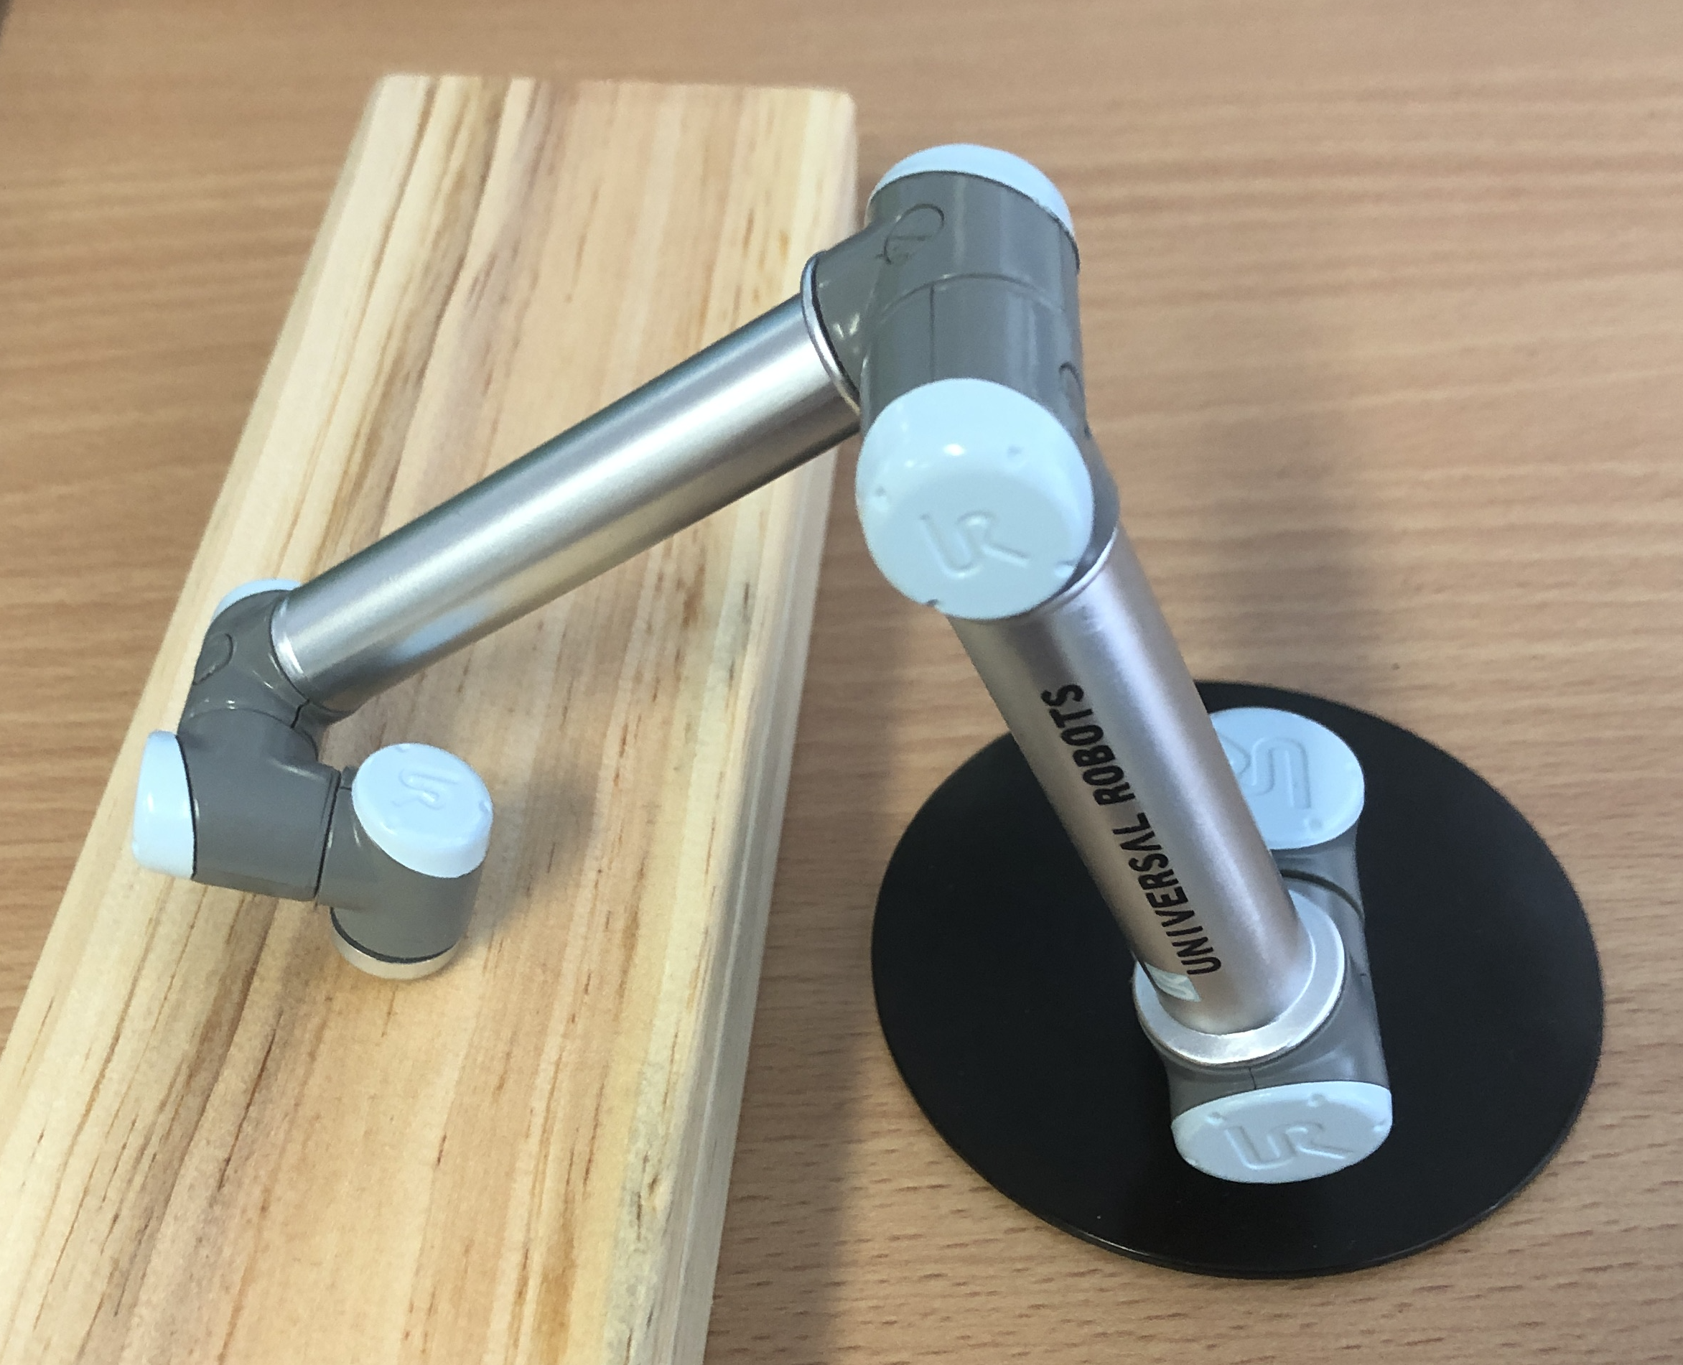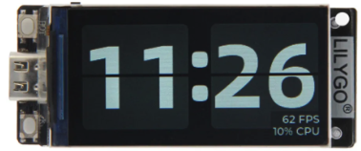

- Build the 6-DoF robot model from 3D-printed or laser-cut parts.
Consider signing up for the Maskers Club and required inductions.
- Each of the 6 axes should be equipped with a sensor (e.g. potentiometer), which is to be fed as an input to a TTGO ESP32 controller (provided).
- Write a program on the TTGO to display the 6 joint angles.
- With the forward-kinematics calculate and display the gripper position in x,y,z
for the real UR5.
- Visualize the robot configuration graphically on the TTGO.
- Link your TTGO via WIFI to the UR5’s router.
- Use button-1 on the TTGO for establishing and stopping a link to the real UR5.
- Use button-2 on the TTGO close/open the gripper on the real UR5.
- Implement a recording & playback function on the TTGO for a robot movement sequence.

BUDGET
The maximum budget for this project is $20 per group.
If you would like to get your expenses reimbursed, please submit a reimbursement request with invoices via Concur by the end of week 12 using:
PG 68 00 10 18 BU 00660 Mechatronics
DEMONSTRATION
During your lab session in week 12.
VIDEO
Produce a video of about 1 min. length using time-lapse that shows the full construction of your sculpture in automatic mode.
SUBMISSION
Submit one report per team as a softcopy plus hardcopy with official coversheet incl. declarations of all team members:
- Project design report (pdf), which includes:
- Report on which team member did what
- CAD design
- Software design
- Diagrams, photos, screenshots, plots, etc.
- Bill of Material with costing (budget)
- User Manual
Include page numbers; max 10 pages plus 1 Title page

Do NOT include:
- Program code
- Table of contents, etc.
- Half-empty pages
- Source code (email to project supervisor only, no hardcopy), clearly marking any imported code with referencing the source.
MARKING
70% Functional Performance, Design, Complexity, Innovation
20% Project Design Report
10% Video

