The University of Western Australia
School of Engineering
Prof. Thomas Bräunl

Robot Manipulators and Automation
AUTO4507
Lab Assignment 3 –Group– Serial Robot Points: (1+2+2)+(3+2) = 10
Make yourself familiar with the UR5 robot documentation and the interfacing via Ethernet.
Experiment 1 – Moving in Space
1. 1 Square
- Joint Space
Write a program that moves the robot in a sequence to the 4 corner points of a square of size 20cm. Let the robot stop for 1 second after reaching each position.
- Cartesian Space
Repeat the same experiment, but let the arm move along a straight line

1. 2 Cube
- Joint Space
Write a program that moves the robot in a sequence to the 8 corner points of a cube of size 20cm. Let the robot stop for 1 second after reaching each position.
- Cartesian Space
Repeat the same experiment, but let the arm move along a straight line

1. 3 Circle
Write a program that moves the robot gripper along a circle of diameter 20cm.
Experiment 2 – Vision System

Let the robot arm rest about 50cm above the table with the camera looking down.
Using OpenCV in Python or C++, solve the following tasks.

2.1 Classification
Identify all objects on the table and classify them as either triangle, square, (half-) circle or star shapes using OpenCV function: approxPolyDP
See link for shape detection:
https://stackoverflow.com/questions/11424002/how-to-detect-simple-geometric-shapes-using-opencv
Print out each object’s type.

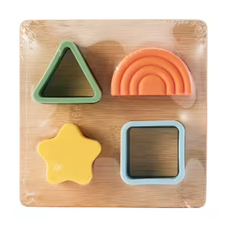

2.2 Calculation
For each detected object:
- Calculate and print the global coordinates of its 2D center-point.
- Move the robot arm so the object’s center is in the center of the camera image.

