The University of Western Australia
School of Engineering
Professor Thomas Bräunl

Robot Manipulators and Automation
AUTO4507
Lab Assignment 2 –Group– Industrial Robot Points: 10
GROUPS: Form groups of 4 students
EQUIPMENT: Nachi Industrial Robot
You must complete the Nachi robot induction with your lab demonstrator before you can start working on the robot.
The robot must not run in autonomous mode if a person is inside the cage.
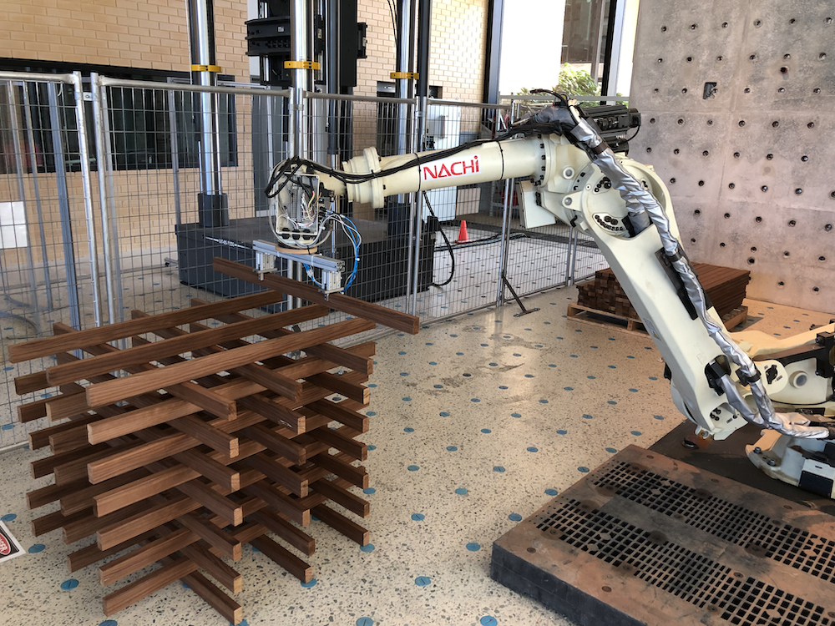

The robot is to complete the construction of a timber stack of 2 layers using 4 timber pieces each (so smaller than in the photo).
The distance of the cross-points from the outer edges of the timber pieces should be calculated as:
Distance = (your_group_number + 1) * 4cm
All timber pieces have the same length of 120cm.
Pre-Lab – Complete before the lab session
- Design the timber stack in a CAD system, using the given length and cross-point distances.
- Plan your gripping and deposit procedure.
Each timber piece has to be picked up with both grippers.

Experiment 1 – Nachi Robot
- Timber pieces will be loaded by hand before a robot run into the feeder table.
- The robot will always take the lowest timber piece from the same pose. It then moves it to the pose of the next timber piece in the stack.
Do not make any changes to the feeder table.
- First, execute these movements in manual mode for testing. That way you can stay inside the fenced area, but you need to hold the dead-man switch.
- Use a provided palette as the basis of your stack.
Do not start directly on the floor to avoid crashing the robot into the floor.
- When depositing the pieces onto the stack, remember that the stackis growing, so your drop-off points will change with every piece.
- Let the robot release the timber piece and fetch the next piece from the feeder table. Repeat this task until the stack is completed.
- Your goal is to complete the stack in a single automatic run without manual intervention.
After your lab session is completed, please clean up the lab and stack the timber pieces back to their original location.

