***UR5:***

The UR5 manipulator used in this project consists of three components:

* The Universal Robots UR5 arm;
* The Robotiq Wrist Camera; and
* The Robotiq 2F-140 Adaptive Gripper

Students are advised to familiarise themselves with the resources referenced below when completing this project.

There are two ways UR5 can be programmed: graphically, using the **PolyScope** Graphical User Interface (GUI); or programmatically, using **URScript**. General information on UR5 can be found in the UR5 User Manual:

[https://s3-eu-west-1.amazonaws.com/ur-supportsite/27421/UR5_User_Manual_en_Global-3.4.5.pdf](https://s3-eu-west-1.amazonaws.com/ur-support-site/27421/UR5_User_Manual_en_Global-3.4.5.pdf)

PolyScope GUI programming involves writing the program as a tree structure. Programs must be written using the UR5 Teach Pendant (a touch screen connected to UR5). Commands can be selected using the GUI and inserted into the tree. Information on basic commands can be found in the PolyScope Manual:

[https://s3-eu-west-1.amazonaws.com/ur-supportsite/27541/Software_Manual_en_Global-3.4.4.pdf](https://s3-eu-west-1.amazonaws.com/ur-support-site/27541/Software_Manual_en_Global-3.4.4.pdf)

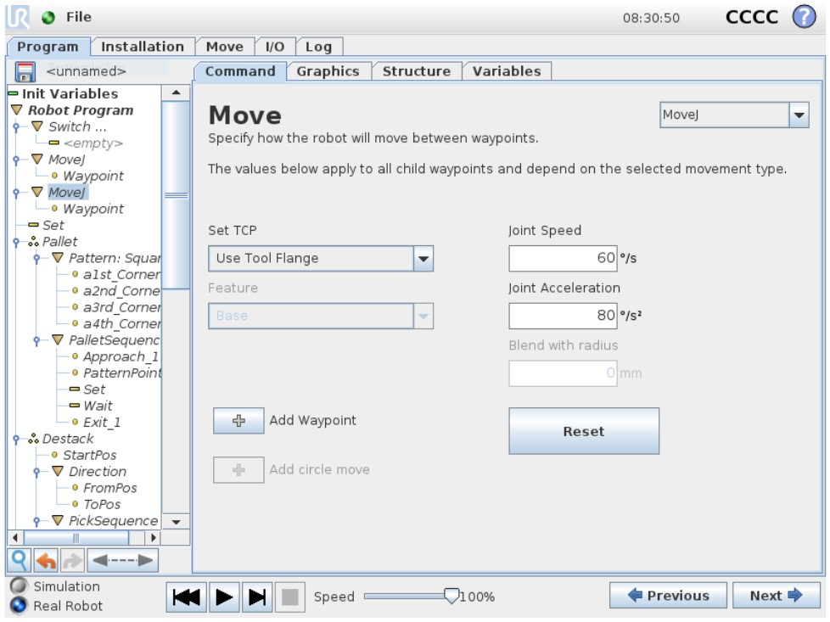

The source code underlying the PolyScope GUI program is written in URScript. An advantage of programming in URScript is that extended access to the Teach Pendant is not required – programs can be written in a text editor, meaning access to the Teach Pendant is only required when uploading and testing the program. Information on program structure, basic commands, and device interfacing can be found in the URScript Manual:

[https://s3-eu-west-1.amazonaws.com/ur-support-site/28901/scriptManual-](https://s3-eu-west-1.amazonaws.com/ur-support-site/28901/scriptManual-3.4.5.pdf)

[3.4.5.pdf](https://s3-eu-west-1.amazonaws.com/ur-support-site/28901/scriptManual-3.4.5.pdf)

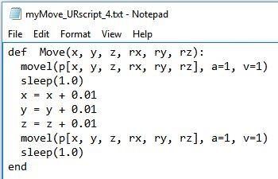

Additional tutorials covering PolyScope GUI and URScript programming can be found here:

[http://www.zacobria.com/universal-robots-knowledge-base-tech-support-forumhints-tips/](http://www.zacobria.com/universal-robots-knowledge-base-tech-support-forum-hints-tips/)

Information on controlling the gripper and camera can be found here in the relevant user manuals:

[Vision_Syst em_PDF_20180725.pdf](https://assets.robotiq.com/production/support_documents/document/Vision_System_PDF_20180725.pdf)

[2F-85_2F140_Instruction_Manual_PDF_20180725.pdf](https://assets.robotiq.com/production/support_documents/document/2F-85_2F-140_Instruction_Manual_PDF_20180725.pdf)